……and so much the more, as ye see the day approaching.
November 20th, 2022

Please stand to worship:
Pg. 456 - Count Your Blessings (Vs. 1, 3, & 4)
Pg. 563 – I Just Want to Thank You, Lord (Vs. 1 & 3)
*Announcements
*Offering for Youth Activities
*Offering & Tithes
Pg. 28 – Great Is Thy Faithfulness

Church Family Thanksgiving Dinner –
Sun., Nov. 27th @ 5 pm.
A time of praise & Worship; turkey & ham provided.
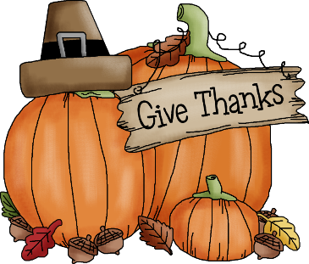

Ezra 3:11
And they sang together by course in praising and giving thanks unto the LORD

We are thankful for each of you! Pastor & Maria

2Th 2:13 But we are bound to give thanks alway to God for you…
Terry, Leena, & Gabe
Cecil & Janice
Judy
Nedra
Brian, Nicole, Sydney, Kate, Wyatt, & Aryn
George
Rick
Jacob
David & Sarah
Michael & Emily
Laura
Nancy
Don
& so many more!!!

