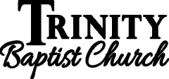
17


April 2nd, 2023
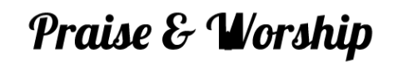
Please stand to worship:
Pg. 334 – At Calvary
Pg. 343 – At the Cross
*Announcements
*Offering for Youth
*Offering & Tithes
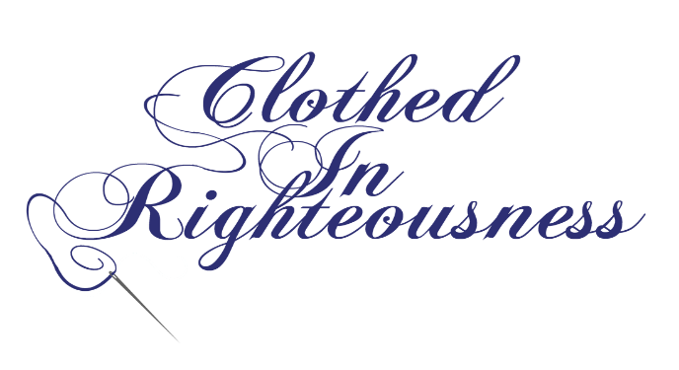
Pg. 321 – At the Right Time (Vs. 1 & 3)

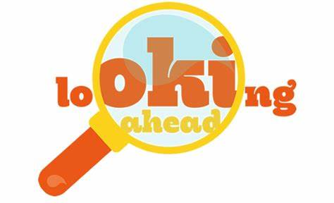

Sun., April 9th – Easter Sunday
Fri., April 21st - City of Merriam staff picks up large items such as furniture, appliances, carpets/rugs, and miscellaneous items.
Sun., April 30th – Seniors meet at 4 pm in Fellowship Hall for a time of fellowship! See David or Sarah!
Thank you so much! Thank you for coming out yesterday & working on some spring cleaning! We got some things done and we had wonderful fellowship!
Connection: GuestTBC
Password: Psalm122:1

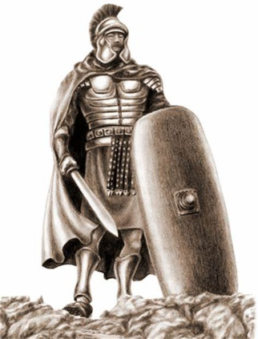
Righteousness conveys a sense of justice, justness, or divine holiness. God is the standard of righteousness. To be righteous is to be right with God.


