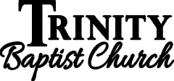
17

Living Righteously in a Wicked World
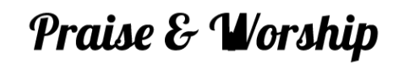
July 23rd, 2023

Please stand to worship:
Pg. 97 – I Love to Tell the Story (V. 1, 2, & 4)
Pg. 92 – I Know That My Redeemer Liveth
*Announcements
*Offering & Tithes
Pg. 88 – Jesus Saves
(V. 1, 2, 3)
*Womens’ Bible Study –Every Monday in July – 10 am in Fellowship Hall – Being a Woman of God. 2 more studies left!
*Children’s Church Workers for July – Brian & Nicole
*August 13th - Missionary Gary Hampton, Savoonga, Alaska (Morn. Serv.)
*August 13th – Going Away Fellowship for Jacob Harrell following evening services. See Maria for more information!
*August 20th - Back to School Bash 5 pm

*September 3rd – Stay tuned for changes!
Connection: GuestTBC
Password: Psalm122:1

A little compromise generally leads to more and more tearing down the righteousness of God in your mind and heart!



