
17

Living Righteously in a Wicked World
August 6th, 2023


Please stand to worship:
Pg. 272 – A Child of the King
*Announcements
*Offering & Tithes
Pg. 284 – A Shelter in the Time of Storm
Pg. 149 – Sheltered in the Arms of God

*Trinity Kids - Workers for July/August – Brian & Nicole
*August 13th - Missionary Gary Hampton, Savoonga, Alaska (Morn. Serv.)
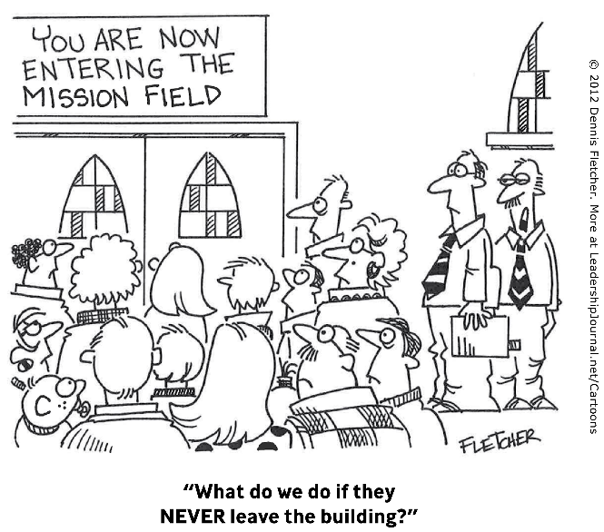
*August 13th – Farewell Fellowship for Jacob Harrell following evening services. See Maria for more information!
*August 20th – Teachers meeting following morning service (Including teachers for Trinity Kids).
*August 20th - Back to School Bash 5 pm *Bring something “school lunchy”!

*September 3rd – Stay tuned for changes!
Connection: GuestTBC
Password: Psalm122:1

John 4:35
Say not ye, There are yet four months, and then cometh harvest? behold, I say unto you, Lift up your eyes, and look on the fields; for they are white already to harvest.

