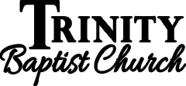
17

Living Righteously in a Wicked World
August 20th, 2023
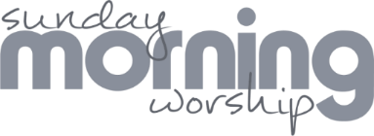

Please stand to worship:
Pg. 343 – At the Cross
Pg. 342 – Kneel at the Cross
*Announcements
*Offering & Tithes
Pg. 344 – He Did It All for Me
Pg. 357 – Beyond the Cross

*Trinity Kids - Workers for August – Brian & Nicole

Wherefore the law was our schoolmaster to bring us unto Christ, that we might be justified by faith.
But after that faith is come, we are no longer under a schoolmaster.
For ye are all the children of God by faith in Christ Jesus. Gal. 3 : 24-26
*August 20th – Teachers meeting following morning service up in front (Including teachers for Trinity Kids).
*August 20th - Back to School Bash 5 pm *Bring something “school lunchy”! *Fellowship Hall
*September 3rd – Stay tuned for changes!

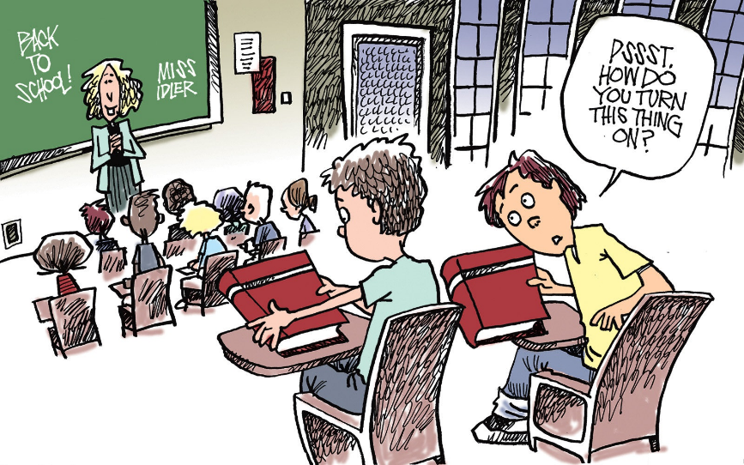

Connection: GuestTBC
Password: Psalm122:1

